**Density Based Traffic Management System Using Canny Edge Detection Technique**

# Agrini Chaturvedi 17BEC005, Aditya Jain 17BEC003

Institute of Technology, Nirma University, Professor B. D. Fataniya, Electronics and Communication, Ahmedabad, India

**Abstract**: With the exponential growth of the human population it is but obvious that there will be an increase in the number of vehicles in our streets and roads. Also, the timer based or man-based management of the traffic density are the things of the past. In the cities there is also no or very little place available to increase the size of the pre-existing infrastructure. So, the solution to our problem lies in making the best use of our pre-existing resources and projects. The method explained in this paper proposes to be one of the steps in this direction. In this paper we explain the proposed method of canny edge detection. Also, in this paper proper knowledge about the different image processing techniques that could be employed, with a working software model of the same is explained which is developed by employing the technique of Canny Edge Detection.

**Keywords**: MATLAB Programming, Sobel Edge, Canny Edge, Gaussian Filter, Convolution.

# I Introduction

Traffic congestion is one of the elementary problems that is putting a brake on the speed of growth of the metropolitans around the world. South Asia is no exception. In a study conducted recently by the World Bank has shown that the average speed in Dhaka has reduced from 21kmph in 2006 to 7kmph in 2006. The presence of unmotored vehicles and hand pulled carts, which is unique in this part of the world, has also its perils for other commuters when they are on our roads. Also building new flyovers or expressways require huge capital investment and time, both of which we lack, so we have to look for solutions that can be employed in our pre-existing infrastructure.

To tackle with such issues a method has been put forward in [1] and explained in this article. This method employs image processing tools to be able to distinguish between an empty road and a threshold amount of traffic that is present on that particular stretch. Edge detection is proposed here, that distinguishes or measures the traffic by “seeing” and comparing the number of boundaries that is present in the given image with a reference image.

There are different Edge based image processing techniques available, such as Sobel, Prewitt, Canny, etc. In this paper we aim to solve the traffic problem by employing Canny Edge Detection technique, mostly because it is 1) Robust to noise 2) Localizes the edge and lastly 3) There is not too many or too little response, making it an ideal candidate for the same. A comparison between different edge-based image processing techniques is given in figure (1) and figure (2).

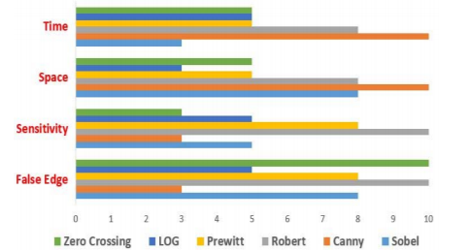

Figure 1. Comparison of Different Edge Techniques [1]

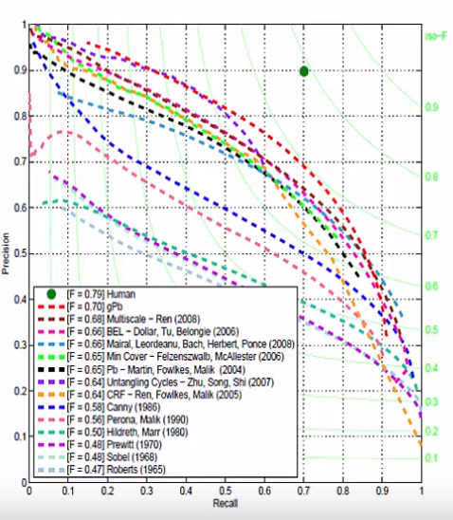

Figure 2. Precision Vs. Recall Graph for Different Edge Techniques [2]

Where for image (2),

Precision= (Result of Method∩Ground Truth)/Result of method.

And, Recall= (Result of Method∩Ground Truth)/Ground Truth.

In this method the white points are measured in the given image with respect to the reference image which is bound to have less of it. By defining certain limit to the amount of white points present, we can change the green light or the red light time of the different intersection of a crossing.

In section II of this paper, we explain a little bit about the different edge detection techniques. In section III we examine the proposed Canny Edge Detection technique. In section IV we compare image detection technique with other methods present for management of traffic density and finally in section V we discuss the algorithm and the code that we are employing to implement this technique.

# II Different Edge detection techniques

Edge detection is very important terminology in image processing and for computer vision. Edge detection is the forefront of image processing for object detection, so it is crucial to have a good understanding of edge detection operators. There are many different methods for edge-based object detection. However, in our present study we discuss only Prewitt, Sobel and Canny methods in detail. Before performing any technique, we have to convert an RGB image to Grayscale image which in MATLAB terms means converting a three-dimensional matrix into two dimensional.

* 1. *Prewitt Edge Detection*

This technique was proposed in [2]. The algorithm for this technique is 1) Smoothing by Gaussian Blur 2) Convolute the image with Prewitt operator to get the x and y gradients for each pixel and 3) Calculating the absolute intensities and orientation of the edge. Prewitt operator is $\begin{matrix}1 & 0 & -1 \\ 1 & 0 & -1 \\ 1 & 0 & -1\end{matrix}$ for y direction and similarly for x direction is employed. The operator is not as accurate as other operators, so it is not widely used now-a-days.

*1.2* *Sobel Edge Detection*

This technique is similar to the aforementioned Prewitt Technique but has the convolution operator as $\begin{matrix}1 & 0 & -1 \\ 2 & 0 & -2 \\ 1 & 0 & -1\end{matrix}$ for y direction and similarly for x direction.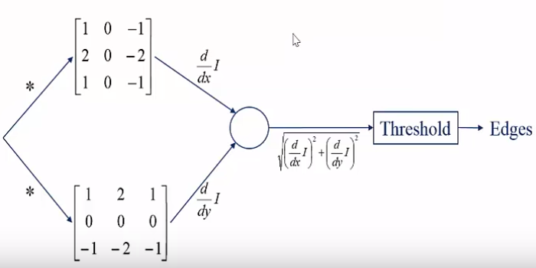

**Image I**

Figure 3. Summary of Sobel Technique [2]

RGB IMAGE

GRAY SCALE

# III Canny Edge Detection Technique.

In the output produced by Sobel techniques few more steps are added to give us the Canny Edge Detection Technique. The result produced by the convolution of the Sobel operator is taken in magnitude as well as the direction of the resulting sum which is determined. This helps in 1) Reduction in false positive as well as false negative 2) Localization of response and 3) Not too much response.

What happens is the direction factor that is added in this helps in coping with too many responses of the edge as it can accommodate the edges that are neither in x nor in y direction(s).

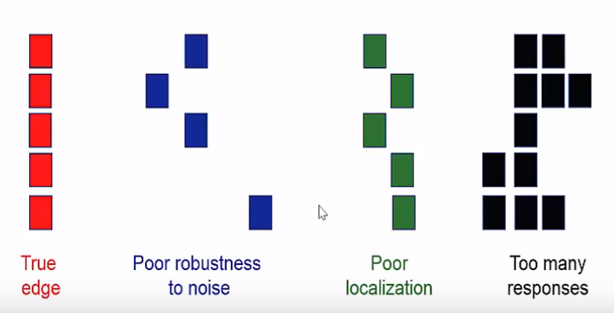

Figure 5. Different Type of Edge Errors. [2]

Also, here, instead of a single threshold value, there are two threshold values (hysteresis), the high as well as low. So, recognition works in this as follows, if an edge is above high, it is detected and if an edge is below low it is undetected. If an edge lies in between the two thresholds and it is connected to an edge that is above high than it is detected otherwise not.

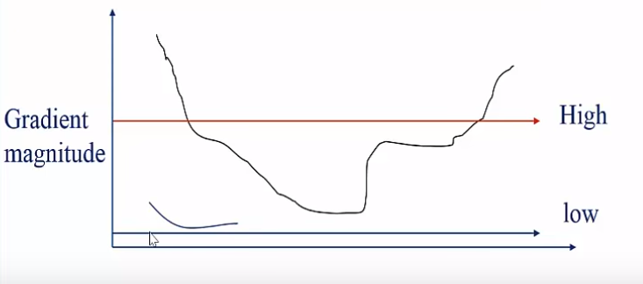

Figure 6. Hysteresis Threshold Used in Canny Edge [2]

# IV Algorithm

# The algorithm that we have worked upon takes the input for one corridor at a time. After the current traffic conditions in the form as an image are input, the image is converted into grayscale along with a reference image of the chosen corridor. Both the images are then converted into binary images after canny edge detection. Now we compare the two binary obtained images for similarity and generate a similarity index. Similarity index is obtained by counting the number of whites in both the images and then taking their ratio. The percentage similarity then decides the open time for a corridor. Lesser the similarity, more is the traffic density on the road, accordingly the open time for the corridor is set.

# V Result

# 

Figure 7. Output

# VI Comparison

Previously different techniques had been proposed, such as infra-red light sensor, induction loop etc. to acquire traffic data which had their fair share of demerits. In recent years, image processing has shown promising outcomes in acquiring real time traffic information using CCTV footage installed along the traffic light. Different approaches have been proposed to glean traffic data. Some of them count total number of pixels [3], some calculate the number of vehicles [4-6].These methods have shown promising results in collecting traffic data. However, calculating the number of vehicles may give false results if the intravehicular spacing is very small (two vehicles close to each other may be counted as one) and it may not count rickshaw or auto-rickshaw as vehicles which

are the quotidian means of traffic especially in South-Asian countries. And counting number of pixels has disadvantage of counting insubstantial materials as vehicles such as footpath or pedestrians. Some of the work have proposed to allocate time based solely on the density of traffic. But this may be disadvantageous for those who are in lanes that have less frequency of traffic.

# VII Conclusion

This article successfully put forward the issue of density-based traffic management system and gave its solution through the application of Canny Edge based Image Processing of real time traffic. By the application of this existing problem of pollution and long hauls at the street which has become the order of the day can somehow be addressed. Also, this paper explained the various prominent edge detection technique.

*Acknowledgments*

We would like to express our deepest gratitude to our teacher, Prof. B. D. Fataniya who gave us such a wonderful opportunity to work upon an all demanding and prestigious topic that of writing a theorized summary of a research article which would prepare us to take head on any effort to write our own research paper in the future. We would also like to thank our University, Nirma University for providing us with the necessary equipment, mentorship and guidance at each and every stage. Last but not the least we would like to thank our parents and friends for their unconditional love and support.

*References*

[1] Tahmid, T., & Hossain, E. (2017, December). Density based smart traffic control system using canny edge detection algorithm for congregating traffic information. In *2017 3rd International Conference on Electrical Information and Communication Technology (EICT)* (pp. 1-5). IEEE.

[2] Lecture 03 Edge Detection by UCF CRCV

[3] Vidhya, K., and A. Bazila Banu. "Density based traffic signal system." *International Journal of Innovative Research in Science, Engineering and Technology* 3.3 (2014): 2218-2222.

[4] https://smart.servier.com/smart_image/gaussian-curve/

[5] Pallavi Choudekar, Sayanti Banerjee and M. K. Muju, “Implementation of image processing in real time traffic light control,” in*3rd International Conference on Electronics Computer Technology*, April, 2011.

[6] T. Semertzidis, K. Dimitropoulos, A. Koutsia and N. Grammalidis, “Video sensor network for real-time traffic monitoring and surveillance,”*The Institution of Engineering and Technology*, Volume 4, Issue 2, June 2010, pp. 103 – 112.

# Caption List

**Fig.1** Comparison of Different Edge Techniques

**Fig.2** Precision vs. Recall Graph for Different Edge Techniques

**Fig.3** Summary of Sobel Technique

**Fig.4** A Gaussian Curve

**Fig.5** Different Type of Edge Errors

**Fig.6** Hysteresis Threshold Used in Canny Edge

**Fig.7** Output